Monthly Newsletter- October/November
TROOP 779

Upcoming Events

October 17
Applebee’s Fundraiser
October 19
Salesmanship Merit Badge

October 24
Community Roots/Tree Planting

October 26
Popcorn Forms Due
October 29
Halloween Social
November 14-15
Popcorn Pick Up
November 20-22
Staley Farm Campout

Important Announcement
Keep selling popcorn!

SEDGE GARDEN UNITED METHODIST CHURCH
SCOUTLANDER.COM
Dear Friends in Scouting,
I am excited to announce our first newsletter! What will you find here? A hard copy to hang on your refrigerators of upcoming events, scouts accomplishments, and acknowledgements for scouts & leaders. Here’s how you can help; still rely on Scoutlander for sign ups and news, email me important announcements or accomplishments you would like us to know about you/your Scout.

Congratulations:
We want to thank River Isacsson for great leadership during his time as SPL as he officially hands the role over to Keith Davis. Keith Davis is a Life Rank and is the Vice Chief of Indian Affairs for the Order of the Arrow (OA). Keith selected Matthew Ritchie and River Isacsson as his ASPL’s, Michael Walsh as Instructor, Ryan Absher as Troop Guide, Hunter Vandiver as OA Troop Rep., Brooks Parker as Chaplain Aide and James Giles as Quarter Master.
Thank You:
We want to take the time to thank all leaders who volunteer either their time weekly, attending monthly committee meetings or driving & assisting scouts on campouts. Thanks to the Thompson family for hosting the Survival Camp Weekend in August, to the Ritchie’s for leading the Applebee’s fundraiser and the Isacsson’s for leading the Popcorn fundraiser. Thanks to all the parents who bring their scouts to weekly meetings.
Halloween Social:
Hope to see all scouts there for a fun relaxed evening. Parents bring a chair and come socialize with other adults! We will have a few activities but mostly just a night to visit with each other.

Fundraising News
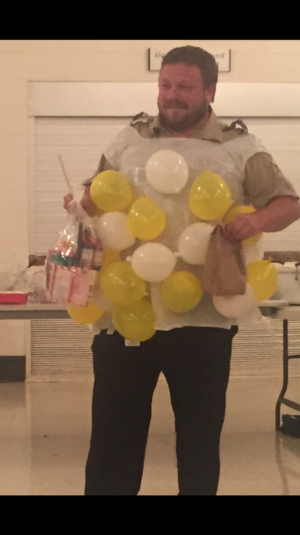

In the Community

Kernersville Chambers of Commerce
On November 9th a group of Scouts will perform a flag ceremony at the COC.
Newsletter Contact Info
christine.isacsson@gmail.com
Leaders
Scout Master
Bill Haps
Assist. Scout Master
Mike Ritchie Aaron Williams
Kevin Keene Jeremy VanDiver
Bart Reed
Committee
Bryan Staley PG Isacsson
Jason Jurkowich David Brown
Catrin Giles Erin Ritchie
Shannon Parker Chris Thompson
Bruce Anderson Gary Smith

We hope you all enjoyed our Popcorn Kickoff. We all enjoyed our popcorn Kernel PG’s good sense of humor! Popcorn is an important part of scouting. It gets our scouts out in the community and it helps fund the scout’s accounts.
Applebee’s Breakfast fundraiser offers two ways to add to your account. You receive a profit from the ticket sales and working at the event on the 17th. Make sure to sign up for work hours.
November will offer another chance to earn account credit. We will begin our annual Christmas tree lot sale. For new scouts, our tree lot sale allows Scouts to sign up to work different days and times selling Christmas Trees at a lot borrowed from the Whicker Family and trees bought from the Parker Family. (Thanks guys!) Scouts make and sell wreaths as well.
Having monthly camping trips along with a High Adventure trip every year can be very costly, so participating in these fundraisers is a great way to fill up your accounts and help ease the cost of Scouting. It also helps fund the Scout Troop which provides Merit Badges and camping equipment for the Troop.
Help Wanted
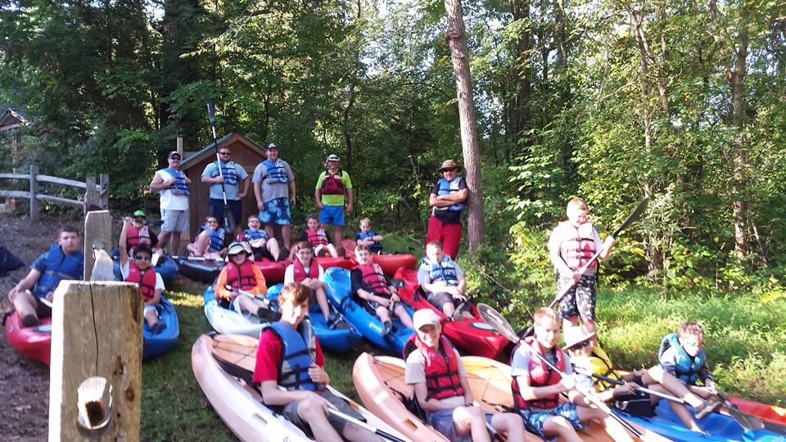
Our Troop is growing by the Monday’s and we could always use a hand. If you have been wanting to volunteer but don’t know where to start you can contact one of our leaders listed to the right for more information. You will need to fill out an Adult application form and take Youth Protection training online. Adult drivers to campouts and activities are always needed and appreciated.

Kayaking Haw River Trip

